Create Site Units From Environmental Fields
Your current project should be the project that contains the plots you are interested in.
From the VPro tab of the ribbon, select “Create Site Units From Environmental Fields”.
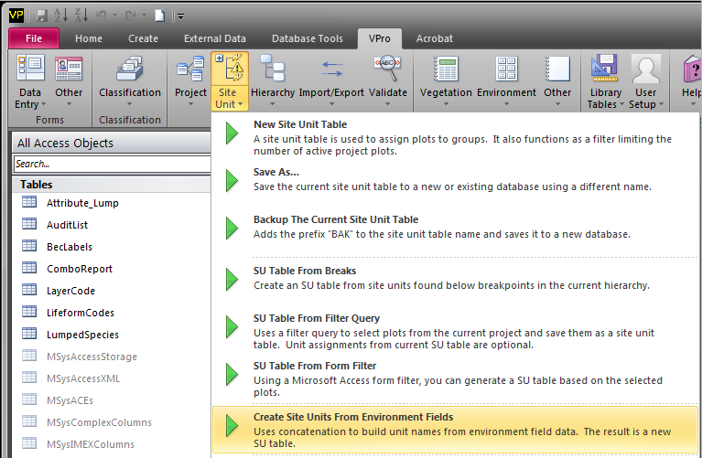
For this example we will create a new site unit list
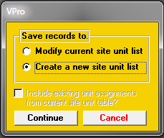

Give your list a meaningful name
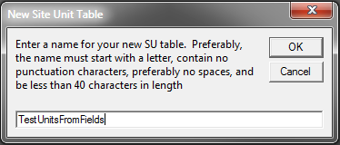
Click Yes to include all the plots
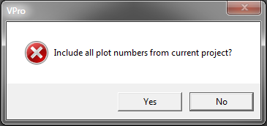
Either select an existing database or create a new one
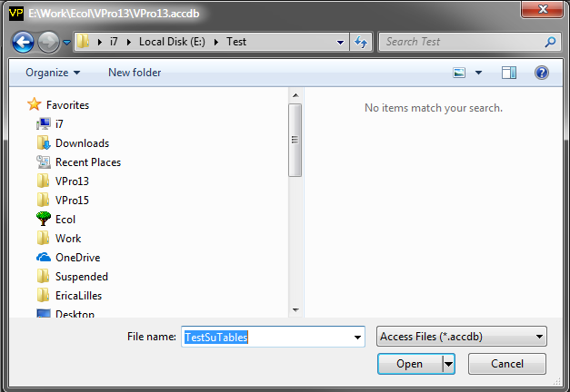

Select the fields you wish to sort the plots into
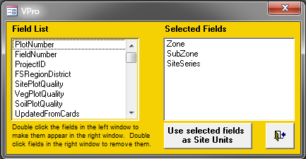
You should now be able to view the structure of your site unit table by selecting the table in the list and clicking the “Site Unit Tree View” button
